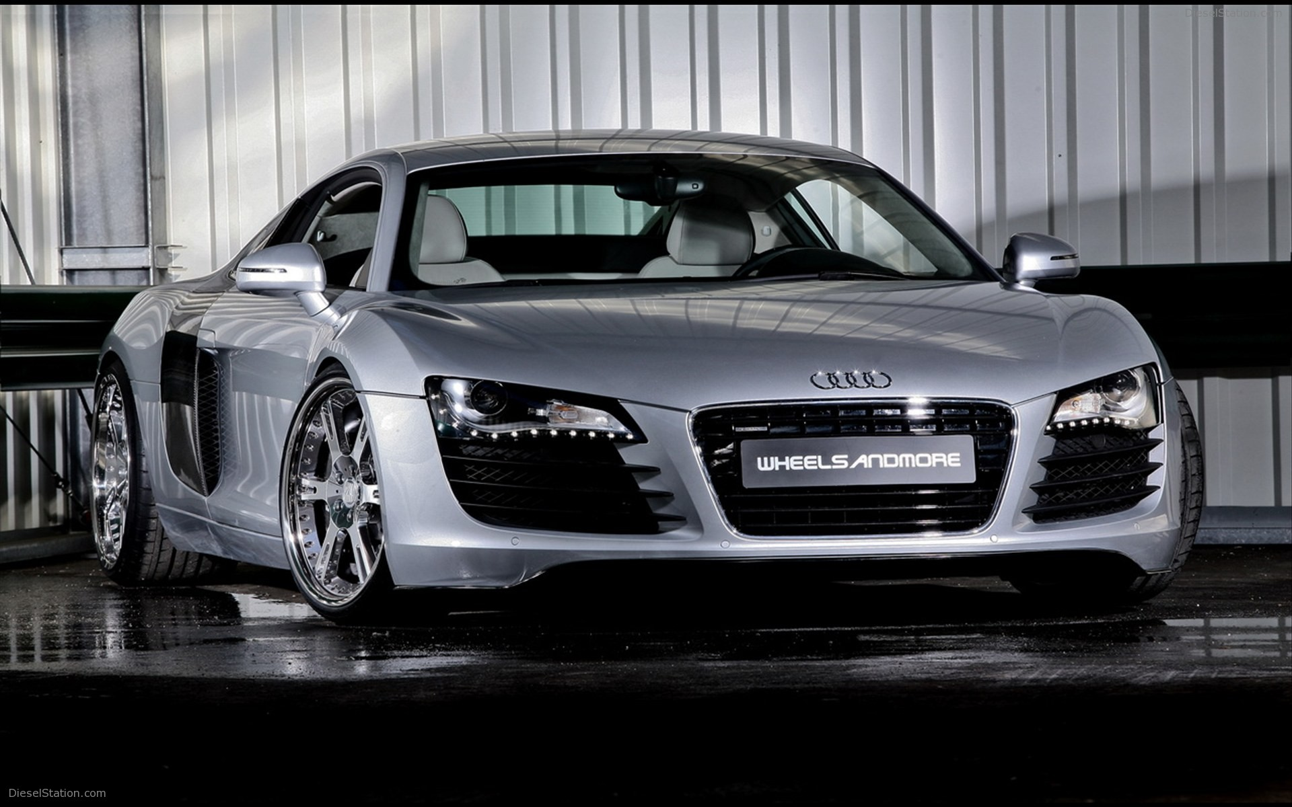
Jackson’s

Auto Sales

Selling Quality Cars Since Last Week

